Home Work Problem Sets: Lectures 1-5

1-1 At the instant of Fig. 11-42, a 2.0 kg particle P has a position vector of magnitude 3.0 m and angle θ₁ = 45° and a velocity vector of magnitude 4.0 m/s and angle θ₂ 30°. Force of magnitude 2.0 N and angle θ₃ =30°, acts on P. All three vectors lie in the xy plane. About the origin, what are the (a) magnitude and (b) direction of the angular momentum of P and the (c) magnitude and (d) direction of the torque acting on P? (HR 11-28)
1-2 A track is mounted on a large wheel that is free to turn with negligible friction about a vertical axis (Fig. 11-49). A toy train of mass m is placed on the track and, with the system initially at rest, the train’s electrical power is turned on.The train reaches speed 0.15 m/s with respect to the track. What is the angular speed of the wheel if its mass is 1.1m and its radius is 0.43 m? (Treat the wheel as a hoop, and neglect the mass of the spokes and hub.) (HR 11-49)
2-3 In Fig. 12-42, a 55 kg rock climber is in a lie-back climb along a fissure, with hands pulling on one side of the fissure and feet pressed against the opposite side. The fissure has width w0.20 m, and the center of mass of the climber is a horizontal distance d =0.40 m from the fissure. The coefficient of static friction between hands and rock is μ₁ =0.40, and between boots and rock it is μ₂ =1.2. (a) What is the least horizontal pull by the hands and push by the feet that will keep the climber stable? (b) For the horizontal pull of (a), what must be the vertical distance h between hands and feet? If the climber encounters wet rock, so that μ₁ and μ₂ are reduced, what happens to (c) the answer to (a) and (d) the answer to (b)? (HR 12-26)
2-4 In Fig. 12-50, a uniform plank, with a length L of 6.10 m and a weight of 445 N, rests on the ground and against a frictionless roller at the top of a wall of height
h = 3.05 m. The plank remains in equilibrium for any value of θ≧ 70° but slips if θ< 70°. Find the coefficient of static friction between the plank and the ground. (HR 12-37)
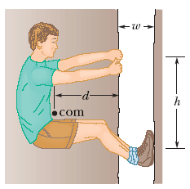
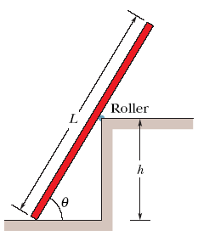
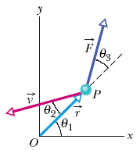
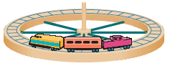

FIG. 11-42 Problem 28. FIG. 11-49 Problem 49. FIG. 12-42 Problem 26. FIG. 12-50 Problem 37.

3-1 In Fig. 15-31, two identical springs of spring constant 7580 N/m are attached to ablock of mass 0.245 kg. What is the frequency of oscillation on the frictionless floor? (HR 15-13)
3-2 In Fig. 15-36, two springs are joined and connected to a block of mass 0.245 kg that is set oscillating over a frictionless floor. The springs each have spring constant k = 6430 N/m. What is the frequency of the oscillations? (HR 15-26)

3-3 For Eq. 15-45, suppose the amplitude x_{m} is given by
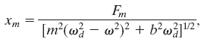
where Fm is the (constant) amplitude of the external oscillating force exerted on the spring by a rigid support in Fig. 15-15. At resonance, what are the (a) amplitude and (b) velocity amplitude of the oscillating object? (HR 15-61)

3-4 In Fig. 15-60, a solid cylinder attached to a horizontal spring (k = 3.00 N/m) rolls without slipping along a horizontal surface. If the system is released from rest when the spring is stretched by 0.250 m, find (a) the translational kinetic energy and (b) the rotational kinetic energy of the cylinder as it passes through the equilibrium position. (c) Show that under these conditions the cylinder’s center of mass executes simple harmonic motion with period T = 2π(3M/2k)^{1/2}
where M is the cylinder mass. (Hint: Find the time derivative of the total mechanical energy.) (HR 15-106)
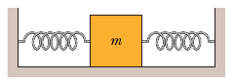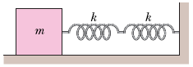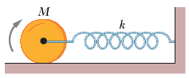
Fig. 15-31 Fig. 15-36 FIG. 15-60 Problem 106.

4-1 A uniform rope of mass m and length L hangs from a ceiling. (a) Show that the speed of a transverse wave on the rope is a function of y, the distance from the lower end, and is given by v = (gy)^{1/2}. (b) Show that the time a transverse wave takes to travel the length of the rope is given by t = 2(L /g)^{1/2}. (HR 16-25)
4-2 The type of rubber band used inside some baseballs and golf balls obeys Hooke’s law over a wide range of elongation of the band. A segment of this material has an unstretched length L and a mass m. When a force F is applied, the band stretches an additional length ΔL . (a) What is the speed (in terms of m, ΔL , and the spring constant k) of transverse waves on this stretched rubber band? (b) Using your answer to (a), show that the time required for a transverse pulse to travel the length of the rubber band is proportional to 1/(ΔL) ^{1/2} ifΔL << L and is constant ifΔL>>L. (HR 16-89)
4-3 Underwater illusion. One clue used by your brain to determine the direction of a source of sound is the time delay Δt between the arrival of the sound at the ear closer to the source and the arrival at the farther ear. Assume that the source is distant so that a wavefront from it is approximately planar when it reaches you, and let D represent the separation between your ears. (a) If the source is located at angleθin front of you (Fig. 17-31), what is Δt in terms of D and the speed of sound v in air? (b) If you are submerged in water and the sound source is directly to your right, what is t in terms of D and the speed of sound v_{w} in water? (c) Based on the time-delay clue, your brain interprets the submerged sound to arrive at an angleθfrom the forward direction. Evaluateθfor fresh water at 20°C. (HR 17-12)
4-4 In Fig. 17-42, a French submarine and a U.S. submarine move toward each other during maneuvers in motionless water in the North Atlantic. The French sub moves at speed v_{F} = 50.00 km/h, and the U.S. sub at v_{US} = 70.00 km/h. The French sub sends out a sonar signal (sound wave in water) at 1.000 × 10³ Hz. Sonar waves travel at 5470 km/h. (a) What is the signal’s frequency as detected by the U.S. sub? (b) What frequency is detected by the French sub in the signal reflected back to it by the U.S. sub? (HR 17-61)
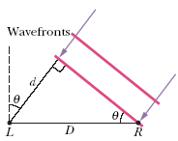
FIG. 17-31 Problem 12. FIG. 17-42 Problem 61.

5-1 The orbit of Earth around the Sun is almost circular: The closest and farthest distances are 1.47× 10⁸ km and 1.52 × 10⁸ km respectively. Determine the corresponding variations in (a) total energy, (b) gravitational potential energy, (c) kinetic energy, and (d) orbital speed. (Hint: Use conservation of energy and conservation of angular momentum.) (HR 13-87)
5-2 The fastest possible rate of rotation of a planet is that for which the gravitational force on material at the equator just barely provides the centripetal force needed for the rotation.(Why?) (a) Show that the corresponding shortest period of rotation is
T = (3π/Gρ)^{1/2} where is the uniform density (mass per unit volume) of the spherical planet. (b) Calculate the rotation period assuming a density of 3.0 g/cm3, typical of many planets, satellites, and asteroids. No astronomical object has ever been found to be spinning with a period shorter than that determined by this analysis. (HR 13-90)
5-3 Several planets (Jupiter, Saturn, Uranus) are encircled by rings, perhaps composed of material that failed to form a satellite. In addition, many galaxies contain ring-like structures. Consider a homogeneous thin ring of mass Mand outer radius R (Fig. 13-55). (a) What gravitational attraction does it exert on a particle of mass m located on the ring’s central axis a distance x from the ring center? (b) Suppose the particle falls from rest as a result of the attraction of the ring of matter. What is the speed with which it passes through the center of the ring? (HR 13-99)
5-4 A certain triple-star system consists of two stars, each of mass m, revolving in the same circular orbit of radius r around a central star of mass M(Fig. 13-54).The two orbiting stars are always at opposite ends of a diameter of the orbit. Derive an expression for the period of revolution of the stars. (HR 13-93)
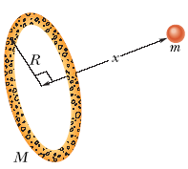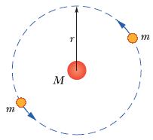
FIG. 13-55 Problem 99. FIG. 13-54 Problem 93.

